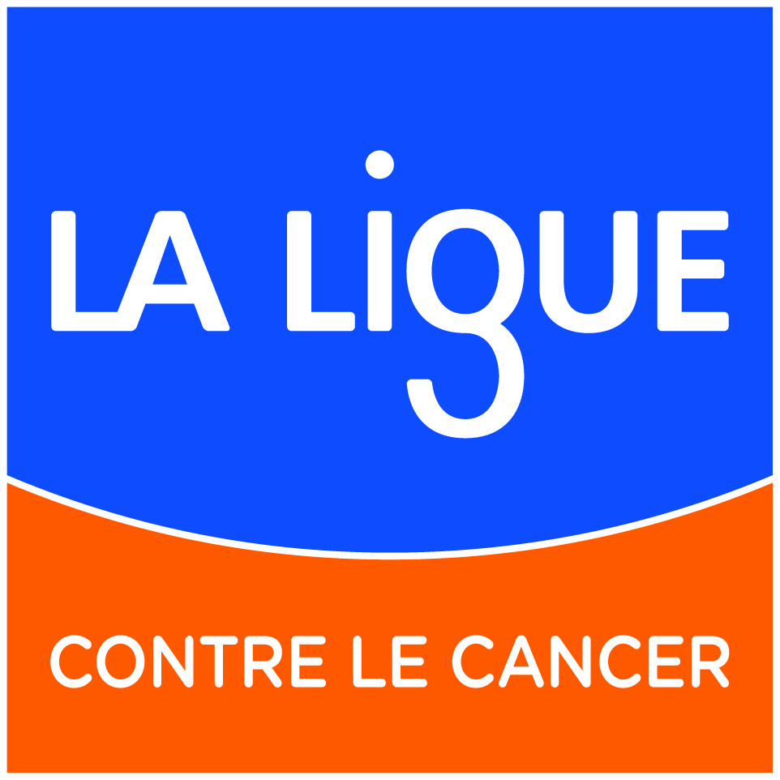


Appel à candidatures 2019

Application file

Designation of early phase clinical trial centres
in adult / pediatric oncology
– CLIP² 2019-2024 –

Name of the CLIP² candidate
Affiliated administrative institution of the CLIP² candidate and the coordinator
Project coordinator
- Name & First Name
Pediatrics project coordinator (if applicable)
- Name & First Name
Designated centre in 2015 as a CLIP² | Yes No
Requested budget for the whole project (€) (36 months)

Soumission en ligne :
http://www.e-cancer.fr/Institut-national-du-cancer/Appels-a-projets/Appels-a-projets-en-cours/CLIPP-2019
Date limite : jeudi 25 octobre 2018 – minuit

Table of contents

Summary 3
I. General presentation of the CLIP² candidate 3
II. Impact of the previous designation for designated centres in 2015 as a CLIP² 5
III. New CLIP² application 6
1. CLIP² candidate’s description 6
2. CLIP² candidate’s organization 6
A. Organization of the early phase activity 6
B. Other services linked to the CLIP² candidate (clinical units/departments are excluded) 7
C. Dedicated staff of the CLIP² candidate 8
D. Accrual capability 9
3. CLIP² candidate’s adult activity 11
A. Clinical trials 11
B. Enrollment 11
C. Audits / Inspections 12
D. External partners 12
4. CLIP² candidate’s pediatrics activity (if applicable) 12
A. Clinical trials 12
B. Enrollment 12
C. Audits / inspections 13
D. External partners 13
5. CLIP² candidate‘ scientific and organizational project 13
6. CLIP² candidate budget 14
IV. Engagements et Signatures 15
V. Annex 22
1. Annex 1 - CLIP² candidate’s early phase adult bibliography 22
2. Annex 2 - CLIP² candidate’s early phase pediatric bibliography 22
3. Annex 3 - CLIP² candidate’s CVs 23

Summary
Summary of the CLIP² application
max 3500 caractères espaces compris – Calibri taille 11

Résumé de la candidature CLIP²
max 3500 caractères espaces compris – Calibri taille 11

General presentation of the CLIP² candidate

A CLIP² candidate consists of a main site (early phase unit) which can be associated to one or more clinical partner sites belonging or not to the same health institution.
It could be clinical units or departments conducting phase II studies in connection with the phase I unit (for example, the hematology department from a hospital university associated to the early phase unit of an anticancer centre or vice versa) or a pediatrics unit conducting early phase trials. In the case of pediatrics, additional fields should be completed.

*N° ORCID (Open Researcher and Contributor ID provides a persistent digital identifier that distinguishes you from every other researcher and, through integration in key research workflows such as manuscript and grant submission, supports automated linkages between you and your professional activities ensuring that your work is recognized
https://orcid.org/register

Identity sheet of differents sites
Main site
Coordinator - name and first name
Title and function :
Medical speciality
N°ORCID
Department/unit
(Name / Adress / City / Zip Code)
Phone / Fax
Email adress:
Affiliated administrative institution
(Name / Adress / City / Zip Code)
For coordinator, attach a short CV with the list of publications relative to early phase clinical trials (Annex 3)
Partner site(s)
Unit/department
Health institution
Legal responsible
Referent - Name and first name
Title and function :
Medical speciality
N°ORCID
Department/unit
(Name / Adress / City / Zip Code)
Phone / Fax
Email adress:
Affiliated administrative institution
(Name / Adress / City / Zip Code)
For referent of each partner site, attach a short CV with the list of publications relative to early phase clinical trials.(Annex 3)
Add as many tables as there are partner sites.
Pediatric Main site
Coordinator - name and first name (if applicable)
Title and function:
Medical speciality
N°ORCID
Department/unit
(Name / Adress / City / Zip code)
Phone / Fax
Email adress:
Affiliated administrative institution
(Name / Adress / City / Zip code)
For pediatric coordinator, attach a short CV with the list of publications relative to early phase clinical trials (Annex 3)
Pediatric partner site 1
Referent - name and first name (if applicable)
Title and function:
Medical speciality
N°ORCID
Department/unit
(Name / Adress / City / Zip code)
Phone / Fax
Email adress:
Affiliated administrative institution
(Name / Adress / City / Zip code)
For referent of each pediatric partner site, attach a short CV with the list of publications relative to early phase clinical trials.(Annex 3)
Add as many tables as there are pediatric partner sites.

Impact of the previous designation for designated centres in 2015 as a CLIP²

Describe the impact of the designation on the site in 2015 and in particular:
- The progression of the early phase activity,
- The development of the structuration put in place,
- The use of allocated resources
- New collaborations (national or international, with other CLIP², with pharmaceutical companies, with translational research teams…)

Describe the impact of the designation for early phase adult activity
Calibri 11, 3 pages maximum

Describe the impact of the designation for early phase pediatric activity
Calibri 11, 3 pages maximum

New CLIP² application

CLIP² candidate’s description

Describe briefly the Health institutions and the facilities dedicated to the early phase research: main site and partner site (s), total area, location within the institution, number of beds, active patient files by localisation, etc…

Describe the CLIP² candidate including its different sites
Calibri 11, 2 pages maximum

CLIP² candidate’s organization

Each of the following part should describe the CLIP² candidate's organization.

Organization of the early phase activity
You should focus, either for adult and pediatric part:
- The governance of the CLIP² candidate
- The modalities of deployment of the human resources between the different sites.
- The articulation and cooperation arrangements, between the main site and the partner site(s) whether they belong or not to the same institution;
- Management of patient care in the framework of early phase activity (medical consultations, examinations, drug administration, samples management, etc.. )
Any other information to help the evaluation committee to understand the functioning of each part of the CLIP² candidate and how patient safety will be managed.

Description of the organization of adult early phase activity including partnership and relation between the main and partner(s) site(s)
Calibri 11, 2 pages maximum

Description of the organization of pediatric early phase activity, including partnership and relation between the main and partner(s) site(s)
Calibri 11, 2 pages maximum

Only for applications involving both adult and pediatric valencies, explain how mutualization will be put in place, and describe the articulation between adult and pediatric parts for the early phase clinical research activity.

Description of the articulation between adult and pediatric parts for the early phase clinical research activity.
Calibri 11, 2 pages maximum

Other services linked to the CLIP² candidate (clinical units/departments are excluded)
List and shortly describe, either for adult and pediatric part, the other services (clinical units/departments are excluded) involved in the design and/or conduct of early phase trials of the CLIP² candidate
- Sponsor unit/department, ie. structure in charge of the sponsorship and the coordination (pharmacovigilance budget, legal, etc.).
- Biostatistics unit/department
- Pharmacology laboratory, Pharmacokinetic laboratory, Pharmacy
- Genetic molecular platforms,
- Translational research or medical biology laboratories,
- Radiotherapy, imaging and/or surgery units
- Biological resource center
- Other medical specialties ensuring specific safety monitoring examinations in early phase trials
- Etc.
You should focus on the articulation and cooperation arrangements, between the adult and/or pediatric part of the CLIP² candidate, and each of theses other actors linked to the early research.

Adult Part
Calibri 11, 3 pages maximum

Pediatric Part
Calibri 11, 3 pages maximum

Dedicated staff of the CLIP² candidate
List of the dedicated staff for the conduct of early phase clinical trials: physicians, nurses, site monitors, TEC, pharmacists… Specify the type of funding (holder, research projects, CLIP², other)
Add as many lines as there are dedicated staff
Main site
Job Category / Function | Status (Holder, CDI, CDD) | FTE dedicated to early phase trials | Name & first name | Funding (project, CLIP², other)
Add as many lines as there are dedicated staff

Partner Site 1
Job Category / Function | Status (Holder, CDI, CDD) | FTE dedicated to early phase trials | Name & first name | Funding (project, CLIP², other)
Add as many lines as there are dedicated staff
Add as many tables as there are partner sites
Pediatric main site
Job Category / Function | Status (Holder, CDI, CDD) | FTE dedicated to early phase trials | Name & first name | Funding (project, CLIP², other)
Add as many lines as there are dedicated staff

Pediatric partner Site 1
Job Category / Function | Status (Holder, CDI, CDD) | FTE dedicated to early phase trials | Name & first name | Funding (project, CLIP², other)
Add as many lines as there are dedicated staff
Add as many tables as there are partner sites

Accrual capability
Detail by type of tumor (adults) the number of new patients cared in the institution in 2017 and the number of patients enrolled in early phase clinical trials

Main site
Tumor type | New patients | Number of patients enrolled in early phase clinical trials | %
Add as many lines as there are tumor types

Partner site 1
Tumor type | New patients | Number of patients enrolled in early phase clinical trials | %
Add as many lines as there are tumor types
Add as many tables as there are partner sites
Pediatric main site
Tumor type | New patients | Number of patients enrolled in early phase clinical trials | %
Add as many lines as there are tumor types

Pediatric partner site 1
Tumor type | New patients | Number of patients enrolled in early phase clinical trials | %
Add as many lines as there are tumor types
Add as many tables as there are partner sites
Describe the tools developed for addressing patients in the institution or from outside, to the early phase unit and relationship
Calibri 11, 1 page maximum

CLIP² candidate’s adult activity

This section should reflect the activity of the early phase clinical trials of the CLIP² candidate for the past three years from 2015 to 2017. Relevant activities are: phases I, I/II and II (are excluding phase II / III or III and part of phase II of phase II / III studies).
The following tables provide the total number of new clinical trials for which the CLIP² candidate (main site and partner(s) site(s)) is sponsor or participant site (industrial or academic trial) and the number of patients enrolled in these trials over a period of 3 years.
A separate Excel Sheet containing a detailed list of these trials is to be completed (together with the requested funding).

Clinical trials
Clinical trials |  | Academic-sponsored trials |  |  |  | CLIP² candidate sponsored trials |  |  |  | Industrial-sponsored trials
 |  | 2015 | 2016 | 2017 | 2018* | 2015 | 2016 | 2017 | 2018* | 2015 | 2016 | 2017 | 2018*
Number of new trials open to enrollment | Phase I
Number of new trials open to enrollment | Phase I/II
Number of new trials open to enrollment | Phase II
*until 30 June 2018
The detail of the institutions or pharmaceutical laboratories promoting the studies should be provided in the paragraph ‘’3.D. External partners’’

Enrollment
Enrollment |  | Academic-sponsored trials |  |  |  | CLIP² candidate sponsored trials |  |  |  | Industrial-sponsored trials
 |  | 2015 | 2016 | 2017 | 2018* | 2015 | 2016 | 2017 | 2018* | 2015 | 2016 | 2017 | 2018*
Number of enrolled patients | Phase I
Number of enrolled patients | Phase I/II
Number of enrolled patients | Phase II
*until June 30, 2018

Audits / Inspections
Type of audit / Inspection  [ex : centre, trial… over the period 2015 - 2018] | year | Audited site | Cause / sponsor of audit | conclusion
Add as many lines as there are audit / inspection
*until June 30, 2018

External partners
List of institutions / pharmaceutical companies which have worked with the centre to conduct early phase clinical trials
Name of institution/ pharmaceutical company | Number of early phase clinical trials (2015-2018*) | Investigational drug(s)
Add as many lines as there are institutions or pharmaceutical companies
*until June 30, 2018

CLIP² candidate’s pediatrics activity (if applicable)

Clinical trials
Clinical trials |  | Academic-sponsored trials |  |  |  | CLIP² candidate sponsored trials |  |  |  | Industrial-sponsored trials
 |  | 2015 | 2016 | 2017 | 2018* | 2015 | 2016 | 2017 | 2018* | 2015 | 2016 | 2017 | 2018*
Number of new trials open to enrollment | Phase I
Number of new trials open to enrollment | Phase I/II
Number of new trials open to enrollment | Phase II
*until June 30, 2018
The detail of the institutions or pharmaceutical laboratories promoting the studies should be provided in the paragraph ‘’4.D. External partners’’

Enrollment
Enrollment |  | Academic-sponsored trials |  |  |  | CLIP² candidate sponsored trials |  |  |  | Industrial-sponsored trials
 |  | 2015 | 2016 | 2017 | 2018* | 2015 | 2016 | 2017 | 2018* | 2015 | 2016 | 2017 | 2018*
Number of enrolled patients | Phase I
Number of enrolled patients | Phase I/II
Number of enrolled patients | Phase II
*until June 30, 2018

Audits / inspections
Type of audit / Inspection  [ex : centre, trial… over the period 2015 – 2018*] | year | Audited site | Cause / sponsor of audit | conclusion
Add as many lines as there are audit / inspection
*until June 30, 2018

External partners
List of institutions / pharmaceutical companies which have worked with the centre to conduct early phase clinical trials
Name of institution/ pharmaceutical company | Number of early phase clinical trials (2015-2018*) | Investigational drug(s)
Add as many lines as there are institutions or pharmaceutical companies
*until June 30, 2018

CLIP² candidate‘ scientific and organizational project
Describe briefly how the CLIP² candidate (either for adult and pediatric parts) plans to complete the tasks / missions described in the call for applications and what are its goals during the period of the designation, including the articulation between the adult and/or pediatric part of the CLIP² candidate, and all the actors linked to the early research.
Describe the scientific and organizational project for adult part
Calibri 11, 4 pages maximum

Describe the scientific and organizational project for pediatric part
Calibri 11, 4 pages maximum

CLIP² candidate budget

Justification
Detail and justify human resources and running costs needs to implement the project
Adult Part
Calibri 11, 1 page maximum

Pediatrics Parts
Calibri 11, 1 page maximum

Funding requested
See financial annex, excel sheet

Engagements et Signatures

Fiches signalétiques des organismes de rattachement
Etablissement de rattachement du CLIP² candidat (destinataire de la notification de la décision de la labellisation et bénéficiaire la subvention INCa)
Nom de l’établissement:

Représentant légal (ou personne dûment habilitée:
Nom Prénom :
(Titre et fonction)
Adresse :
Email :
Statut juridique :
N° SIREN :
Comptable public (oui/non)
Nom prénom de la personne chargée du suivi administratif du dossier :
Adresse de correspondance :

e-mail :
Téléphone :
Etablissement de rattachement du coordonnateur pédiatrique (si différent)

Nom de l’établissement:

Représentant légal (ou personne dûment habilitée¹:
Nom Prénom :
(Titre et fonction)
Adresse :
Email :
Statut juridique :
N° SIREN :
Comptable public (oui/non)
Nom prénom de la personne chargée du suivi administratif du dossier :

Adresse de correspondance :

e-mail :

Engagement du coordonnateur du CLIP² candidat
Je, soussigné(e) : _________________________________________ (nom, prénom)
Coordonnateur du CLIP² candidat

Déclare avoir pris connaissance :

- de l’appel à candidatures «Labellisation de centres d’essais cliniques de phase précoce en cancérologie adulte/pédiatrique - CLIP²-» ;
- du règlement N° 2018-01 relatif aux subventions allouées par l’INCa (consultable à l’adresse suivante : http://www.e-cancer.fr/Institut-national-du-cancer/Appels-a-projets/Reglement-des-subventions);
- et du présent dossier de candidature ;

et m’engage à respecter les dispositions qui me concernent et à mener les missions décrites dans l’appel à candidature au point 3.2,

Date :

Signature : Fait à le

Veuillez joindre les signatures manuscrites et originales et non scannées au dossier papier à envoyer par courrier

Engagement du représentant légal de l’organisme de rattachement du CLIP² candidat et du coordonnateur:___________________________________________(indiquer nom organisme)
Je, soussigné(e), _____________________________________________ (nom, prénom)
Représentant légal
Personne dûment habilitée
(cocher la case correspondante) Cette personne est soit le représentant légal de l’organisme, soit toute autre personne dûment habilitée et bénéficiant d’une délégation de pouvoir ou de signature établie par le représentant légal. En cas de délégation de pouvoir ou de signature, joindre la copie de délégation.

Déclare avoir pris connaissance :
- de l’appel à candidatures «Labellisation de centres d’essais cliniques de phase précoce en cancérologie adulte/pédiatrique -- CLIP²-» ;
- du règlement N° 2018-01 relatif aux subventions allouées par l’INCa (consultable à l’adresse suivante : http://www.e-cancer.fr/Institut-national-du-cancer/Appels-a-projets/Reglement-des-subventions);
- et du présent dossier de candidature ;
- m’engage à respecter l’ensemble des dispositions de ces textes qui concerne l’organisme que je représente ;
- certifie exactes les informations contenues dans ledit dossier ;
- autorise le coordonnateur du CLIP² à mener les missions décrites dans l’appel à candidatures ;
- m’engage à ce que l’organisme que je représente mette en œuvre les missions décrites dans l’appel à candidatures et mène les actions prévues dans le dossier de candidature ;
- m’engage à ce que l’organisme que je représente mobilise, dans les meilleurs délais, les crédits obtenus dans le cadre du présent appel à candidatures et, le cas échéant à les reverser ;
- déclare que l’organisme que je représente est en règle au regard de l’ensemble des déclarations sociales et fiscales (ainsi que des cotisations et paiements y afférant) et au regard des obligations résultant de l’article 10 de la loi n°2000-321 du 12 avril 2000 relative aux droits des citoyens dans leurs relations avec les administrations.

Le ________________________

Cachet de l’organisme :
Signature :

Veuillez joindre les signatures manuscrites et originales et non scannées au dossier papier à envoyer par courrier

Engagement du coordonnateur pédiatrique
Je, soussigné(e) : _________________________________________ (nom, prénom)
Coordonnateur pédiatrique

Déclare avoir pris connaissance :

- de l’appel à candidatures «Labellisation de centres d’essais cliniques de phase précoce en cancérologie adulte/pédiatrique - CLIP²-»
- du règlement N° 2018-01 relatif aux subventions allouées par l’INCa (consultable à l’adresse suivante : http://www.e-cancer.fr/Institut-national-du-cancer/Appels-a-projets/Reglement-des-subventions);
- et du présent dossier de candidature ;

et m’engage à :
- respecter les dispositions qui me concernent et à mener les missions décrites dans l’appel à candidature au point 3.2,
- transmettre au coordonnateur du CLIP² les données d’activité du site partenaire telles que prévues au point 3.2.2 de l’appel à candidatures.

Date :

Signature : Fait à le

Veuillez joindre les signatures manuscrites et originales et non scannées au dossier papier à envoyer par courrier

Engagement du représentant légal de l’organisme de rattachement du coordonnateur pédiatrique _____________________________________________ (indiquer nom organisme)
Je, soussigné(e), _____________________________________________ (nom, prénom)
Représentant légal
Personne dûment habilitée
(cocher la case correspondante) Cette personne est soit le représentant légal de l’organisme, soit toute autre personne dûment habilitée et bénéficiant d’une délégation de pouvoir ou de signature établie par le représentant légal. En cas de délégation de pouvoir ou de signature, joindre la copie de délégation.

Déclare avoir pris connaissance :
- de l’appel à candidature «Labellisation de centres d’essais cliniques de phase précoce en cancérologie adulte/pédiatrique - CLIP²-»,
- du règlement N° 2018-01 relatif aux subventions allouées par l’INCa (consultable à l’adresse suivante : http://www.e-cancer.fr/Institut-national-du-cancer/Appels-a-projets/Reglement-des-subventions);
- et du présent dossier de candidature ;

m’engage à :
- respecter l’ensemble des dispositions résultant des textes ci-dessus qui concerne mon organisme,
- autoriser le coordonnateur pédiatrique à mener les missions décrites dans l’appel à candidatures ;
- transmettre au coordonnateur du CLIP² les données d’activité du site partenaire telles que prévues au point 3.2.2 de l’appel à candidatures.
- le cas échéant, m’engage à ce que l’organisme que je représente mobilise, dans les meilleurs délais, les crédits obtenus dans le cadre du présent appel à candidatures.

Le ________________________

Cachet de l’organisme :
Signature :

Veuillez joindre les signatures manuscrites et originales et non scannées au dossier papier à envoyer par courrier

Ajouter autant de formulaires que d’équipes participantes

Engagement du site clinique partenaire
Nom de l’organisme:______________________________

Signature du représentant légal du site partenaire:

Je, soussigné(e),
Représentant légal
Personne dûment habilitée
(cocher la case correspondante) Cette personne est soit le représentant légal de l’organisme, soit toute autre personne dûment habilitée et bénéficiant d’une délégation de pouvoir ou de signature établie par le représentant légal. En cas de délégation de pouvoir ou de signature, joindre la copie de délégation.

Déclare avoir pris connaissance :
- de l’appel à candidature «Labellisation de centres d’essais cliniques de phase précoce en cancérologie adulte/pédiatrique - CLIP²-»,
- et du présent dossier de candidature,

m’engage à :
- respecter l’ensemble des dispositions qui concerne mon organisme et à mener les missions décrites dans l’appel à candidatures ;

Cachet de l’organisme
Signature : Fait à le

Signature du référent du site partenaire:
m’engage à :
- respecter l’ensemble des dispositions qui me concernent, à mener les missions décrites dans l’appel à candidature au point 3.2,
- transmettre au coordonnateur du CLIP² les données d’activité du site partenaire telles que prévues au point 3.2.2 de l’appel à candidatures.

Signature : Fait à le

Veuillez joindre les signatures manuscrites et originales et non scannées au dossier papier à envoyer par courrier

Délai : jeudi 25 octobre 2018 (minuit)

Format papier comprenant :

- 1 exemplaire original du présent dossier (format Word) et du bilan d’activité et demande financière (format excel) (signatures originales et non scannées) ;

à l’adresse suivante (cachet de la poste faisant foi) :
Institut National du Cancer – INCa
AAC CLIP labellisation 2019
52, avenue André Morizet
F - 92513 Boulogne-Billancourt cedex

ET

Format électronique :

Le format électronique comporte le présent dossier de candidature et du bilan d’activité et demande financière dument complétés, merci de ne pas ajouter de signatures scannées.
Il doit être transmis en ligne par téléchargement via le site de soumission.

La taille du fichier Word complet ne doit pas excéder 4 Mo. Attention pas de format PDF

Adresse unique pour l’appel à projets :
http://www.e-cancer.fr/Institut-national-du-cancer/Appels-a-projets/Appels-a-projets-en-cours/CLIPP-2019

Annex

Annex 1 - CLIP² candidate’s early phase adult bibliography

List the major scientific publications indexed in peer-reviewed journals with international editorial board or any other significant publications during the last three years (title and references), related to the early phase adult activity of the CLIP² candidate.

NB : Highlight in bold the authors belonging to the concerned site

Bibliography of the main site

Bibliography of the partner site 1

Add as many candidate’s bibliography as there are partner sites

Annex 2 - CLIP² candidate’s early phase pediatric bibliography

List the major scientific publications indexed in peer-reviewed journals with international editorial board or any other significant publications during the last three years (title and references), related to the early phase pediatric activity of the CLIP² candidate

NB : Highlight in bold the authors belonging to the concerned site

Bibliography of the pediatric main site

Bibliography of the pediatric partner site 1
Add as many Pediatrics site’s bibliography as there are partner sites

Annex 3 - CLIP² candidate’s CVs

CLIP² candidate’s CVs have to include all the significant publications during the last three years (title and references), related to the early phase activity.

Coordinator’s CV

Coordonator of main site’s CV
- to insert

Coordonator of pediatric main site’s CV
- to insert

Referents of partner site’s CV

Referent of partner site 1’s CV
- to insert

Referent of partner site 2’s CV
- to insert

Add as many referent’s CV as there are partner sites

Referents of pediatric partner site’s CV

Referents of pediatric partner site 1’s CV
- to insert

Referents of pediatric partner site 2’s CV
- to insert

Add as many pediatric referent’s CV as there are pediatric partner sites

Personne habilitée à signer les conventions

